Project 1 – Portfolio Feedback:
Keep up the BEM
More partials for each section
Mixin is good – so u don’t have to scroll
Can add the font in the css
Update the github link for the newer project
Contact – do the form (don’t show the email address)

Mobile view is good

Desktop view
about & my skills squeeze them
over the break: Rebuild the project in react (optional)

Extra Questions:
cURL vs normal URL? cURL command in terminal – another way to make http request (curl sends http request like the browser) sends the webpage
by default, if it expects html, it will give an html. https (the s is just the ssl). Some apps react have https by default
1-to-1 interview after Christmas (online/offline)? Typed/written?
zoom call, questions live coding (u can google they don’t chat gpt) not as hard as the pyramid. Like the js challenge
Day 12
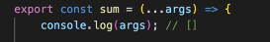
The spread syntax can convert anything to an array? Not everything,
… give flexibility to allow as many parameters as we want and the input turns to an array

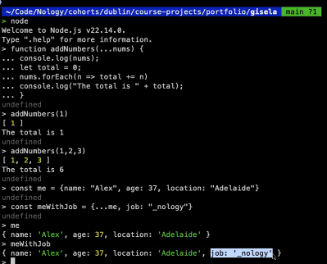

Day 15
const rememberName = (name) => {

const rememberLocation = (name) => {
const locations = {
martyna: "Melbourne",
alex: "Adelaide",
val: "Sydney",
//added in the homework
joaquin: "Darwin"
};
}
const rememberWeather = (location) => {
const weather = {
adelaide: "sunny",
darwin: "stormy",
// sydney: "very sunny",
melbourne: "rainy",

};

The data must be complete and match the case? I tried adding a new person to see how it works? Yes
Hangman assignment – CSS? As long as it is responsive and presentable

